**Beet Seed:**

**1. Using API for practice. Lesson 17.docx create POST, GET, PATCH, DELETE requests with:**

* **variables in the body of the request;**
* **variables in the request parameters;**
* **at least 2 tests for each request.**
* **Add the exported collection to LMS.**

I took screenshots because I tried to export and import and the IDs were disappearing.

Additionally, I tried to create it with “Params” and I was not able to do it.

Create (Post) User 1:

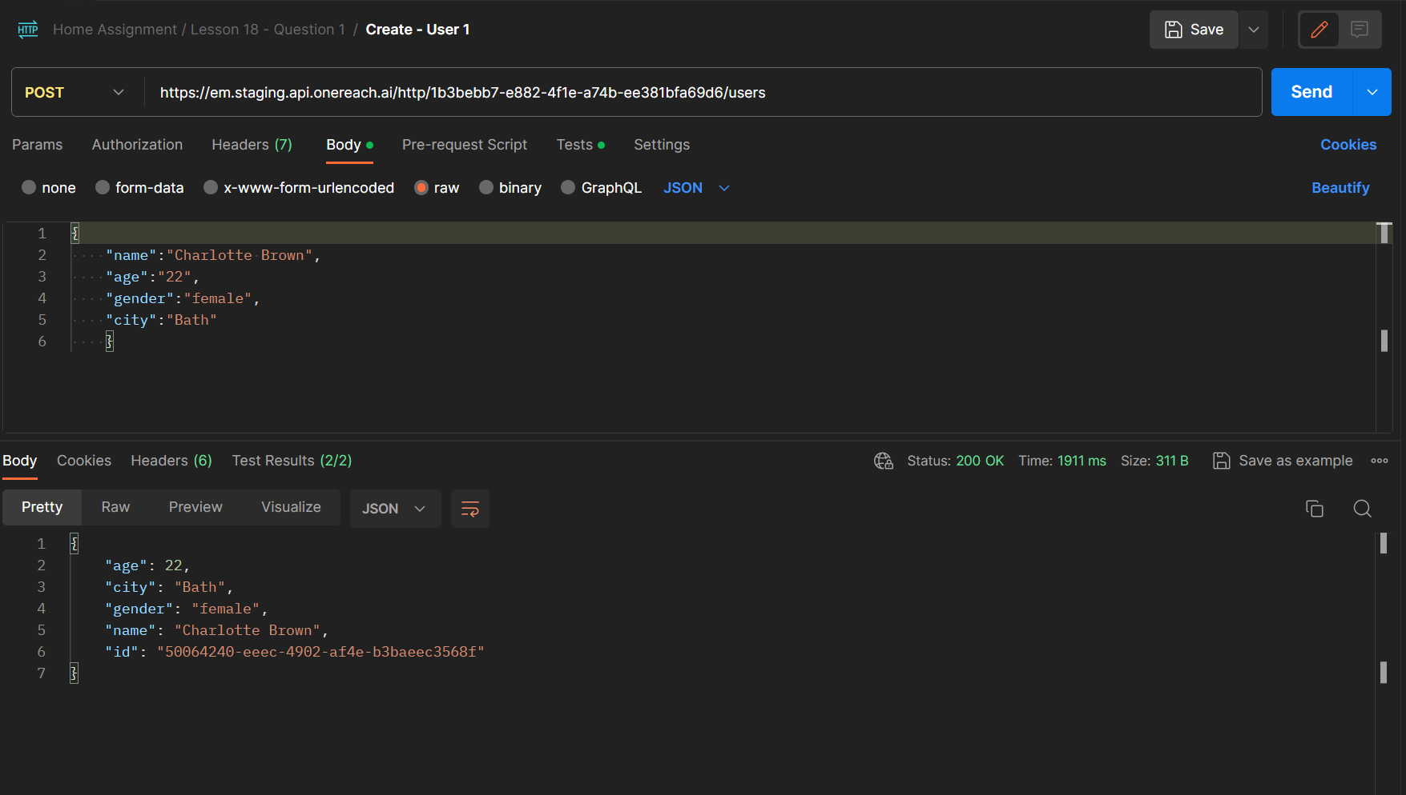

Create (Post) User 2:

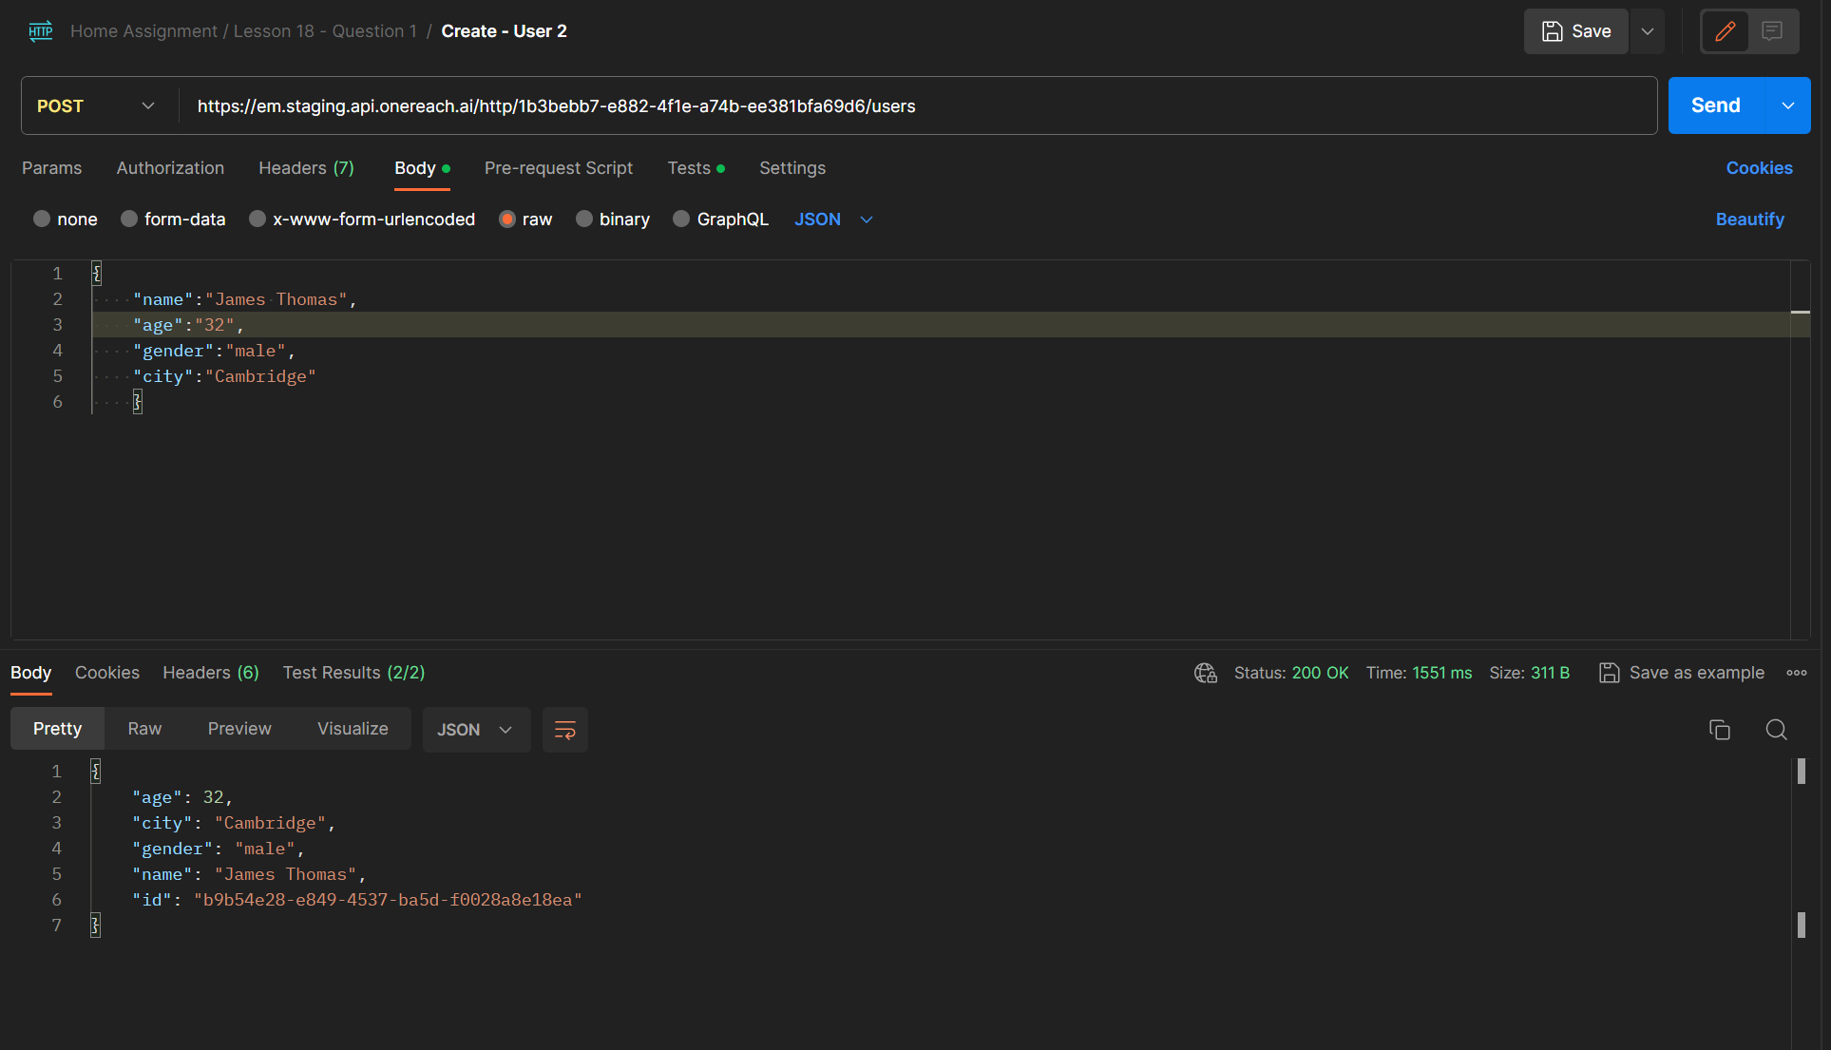

Get User 1:

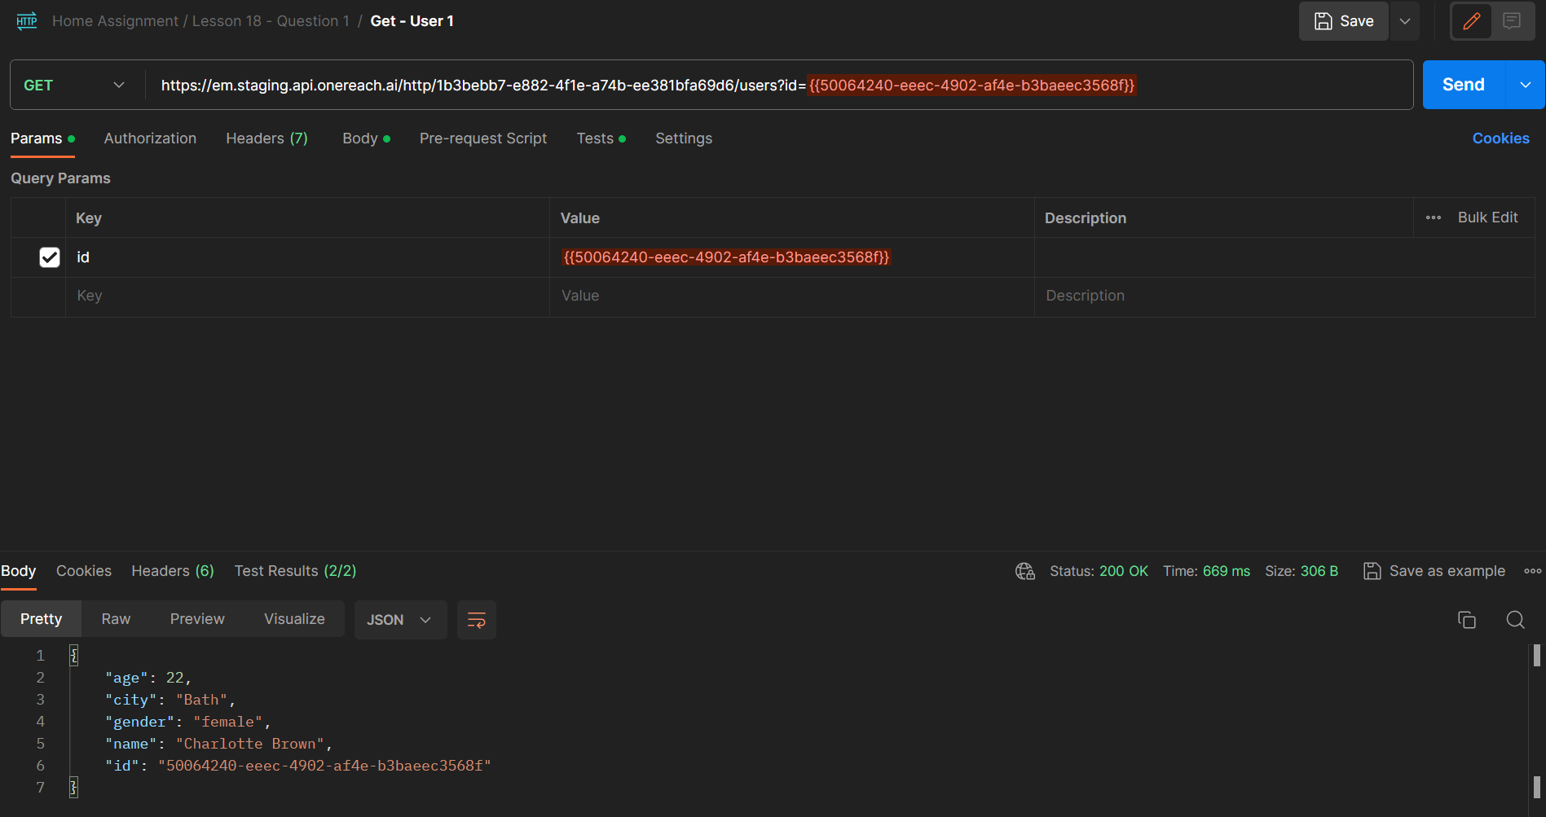

Get User 2:

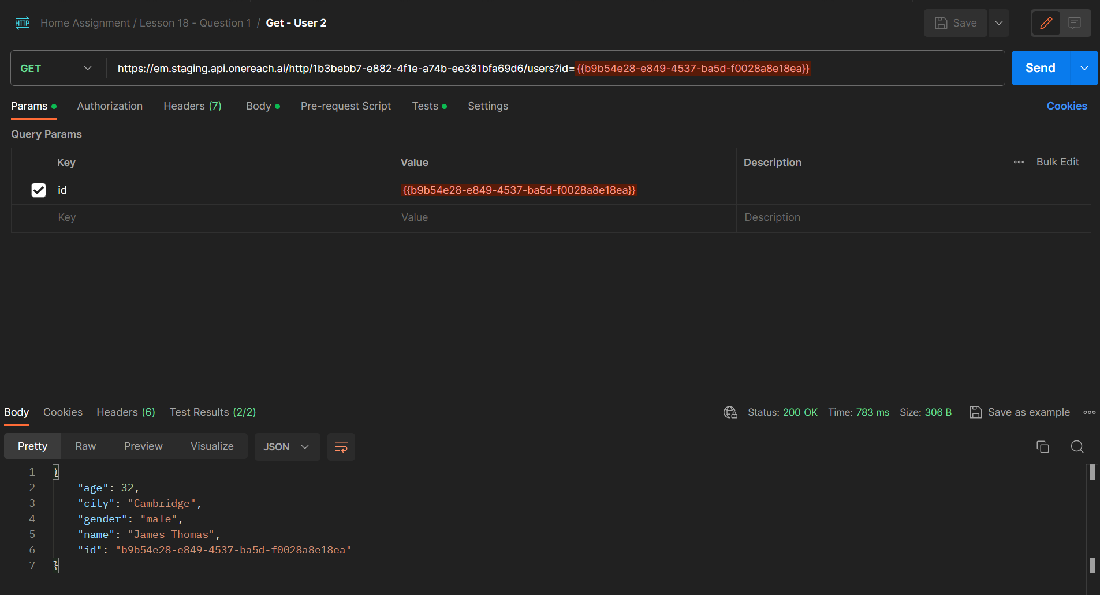

Update (Patch) User 1:

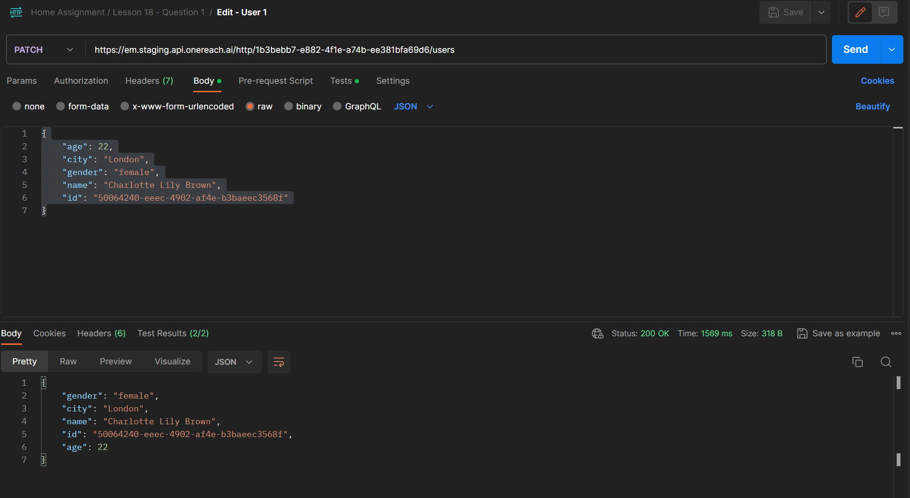

Update (Patch) User 2:

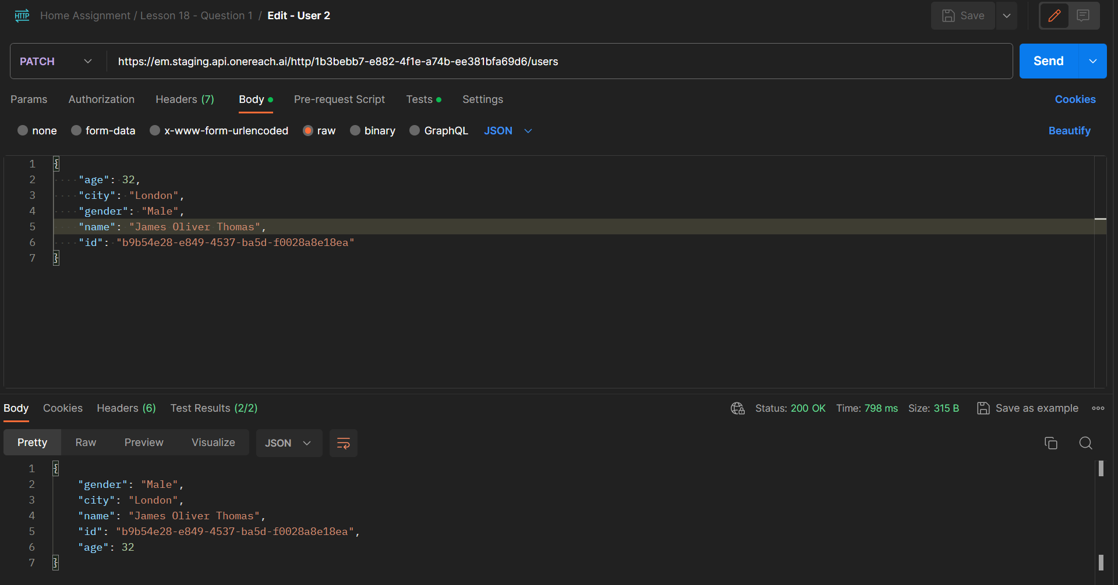

Delete User 1:

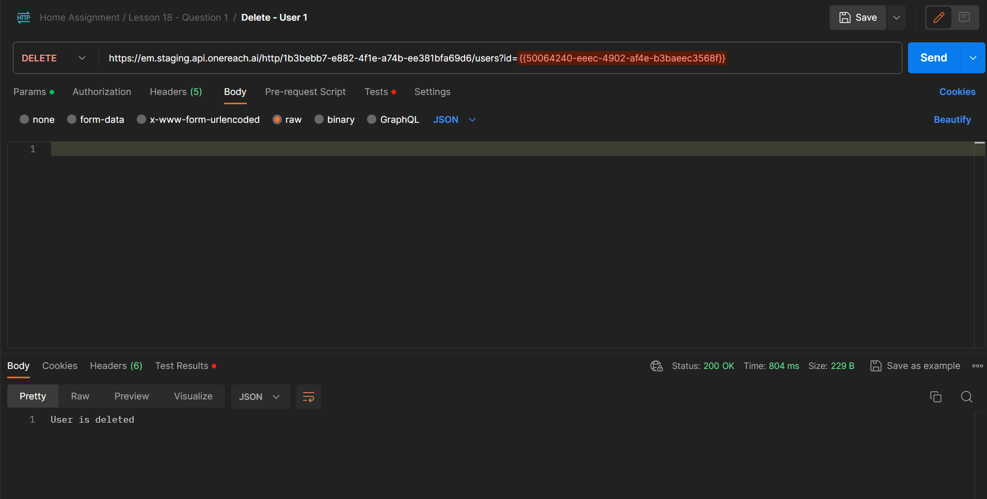

Delete User 2:

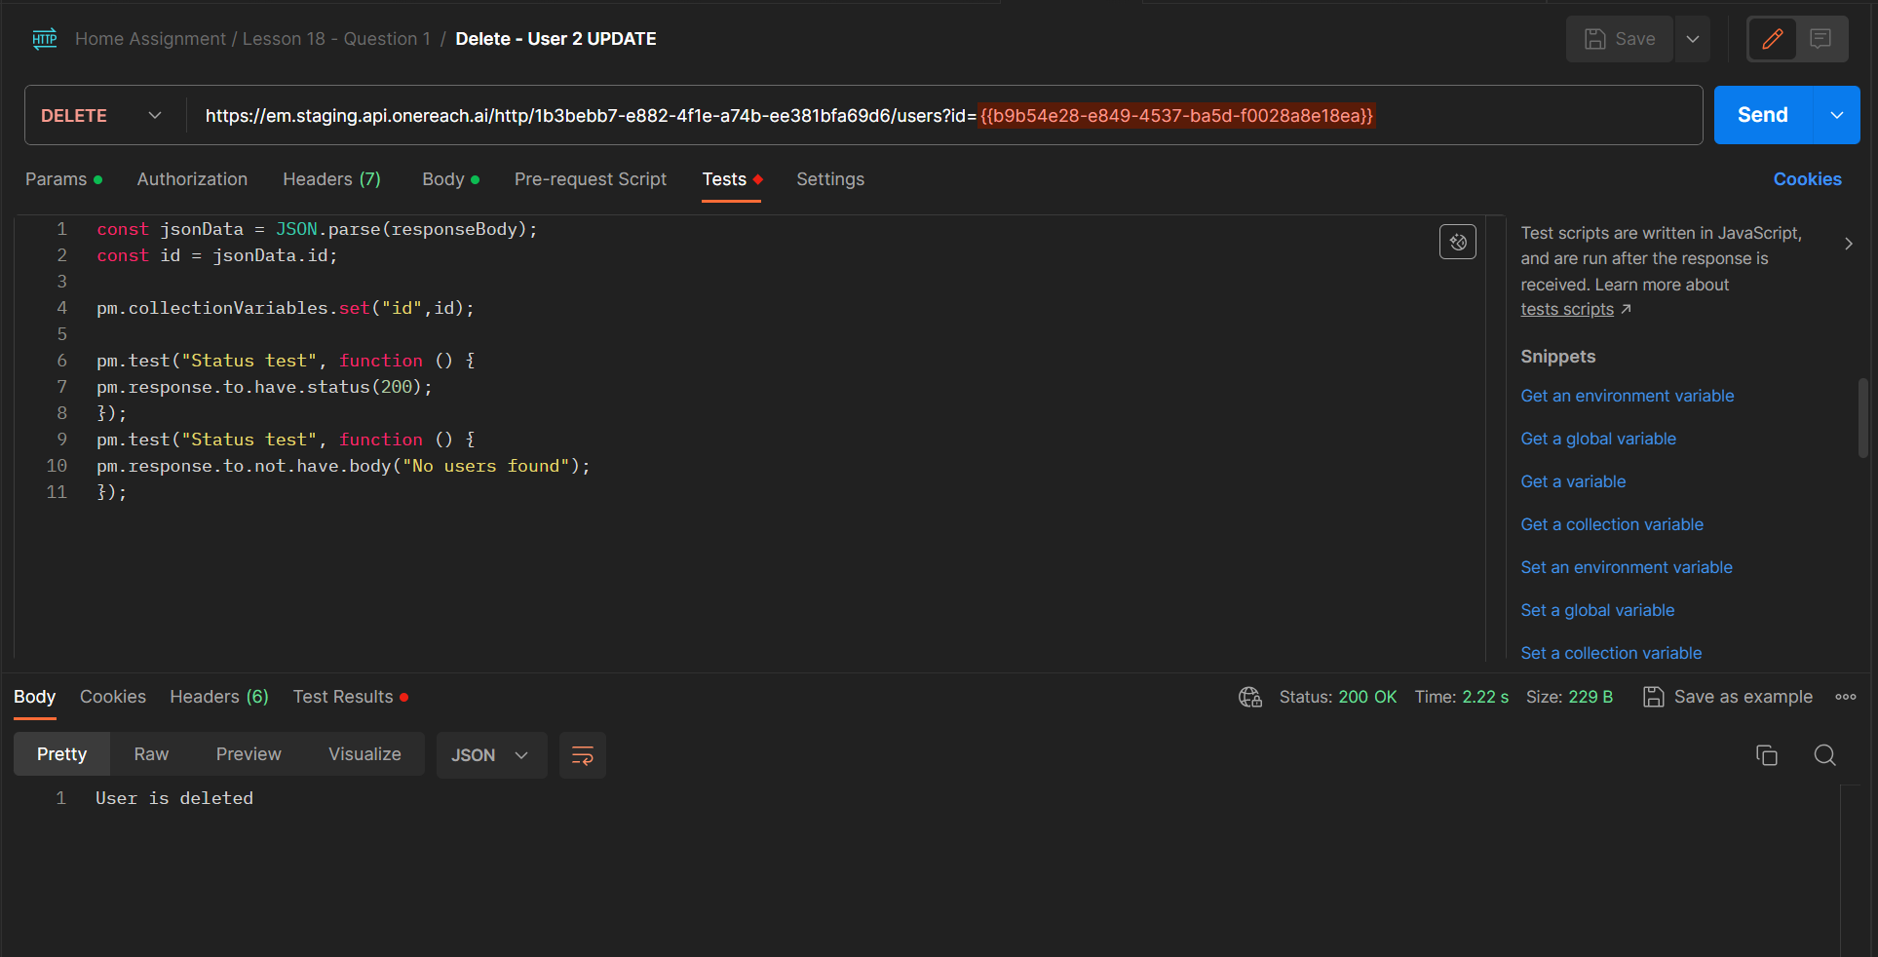

**Beet Sprout:**

**2. For each of the POST, GET, PATCH, DELETE methods, create 1 positive and 1 negative test in the form of requests with:**

* **variables in the body of the request**
* **variables in the request parameters**
* **at least 2 tests for each request.**

| **(1) Successfully Create a User** | |
| --- | --- |
| The API successfully creates a user profile with the parameters provided to it. | |
| **Preconditions:**   * Postman account for tests was created * Tester has access to Postman * New Collection for this Test Run is created with the name “Test API / L18” * API:   + **Schema:** https   + **Base URL:** em.staging.api.onereach.ai/http/1b3bebb7-e882-4f1e-a74b-ee381bfa69d6   + **Resource:** /users | |
| **Test Data:**  {  "name":"Charlotte Brown",  "age":"22",  "gender":"female",  "city":"Bath"  } | |
| **Steps** | **Expected Results** |
| 1. Open Postman and select collection “Test API / L18” | “Test API / L18” is selected |
| 2. Create a new request in that collection | New request is created |
| 3. Select the “Post” method | “Post” method is selected |
| 4. Enter the API URL:  <https://em.staging.api.onereach.ai/http/1b3bebb7-e882-4f1e-a74b-ee381bfa69d6/users> | URL is entered |
| 5. Select “Body” | Body is selected |
| 6. In Body select the option for “RAW” and “JSON” | “RAW” and “JSON” are selected |
| 7. Paste the Test Data in the Body section | Test Data is pasted |
| 8. Click “Send” | Successful HTTP “201 OK” response with user's details and ID |

| **(2) Unsuccessfully Create a user with invalid age** | |
| --- | --- |
| The API is not able to create a user profile because the age is invalid | |
| **Preconditions:**   * Postman account for tests was created * Tester has access to Postman * API:   + **Schema:** https   + **Base URL:** em.staging.api.onereach.ai/http/1b3bebb7-e882-4f1e-a74b-ee381bfa69d6   + **Resource:** /users | |
| **Test Data:**  {  "name":"James Thomas",  "age":"102",  "gender":"male",  "city":"Cambridge"  } | |
| **Steps** | **Expected Results** |
| 1. Open Postman and select collection “Test API / L18” | “Test API / L18” is selected |
| 2. Create a new request in that collection | New Request is created |
| 3. Select the “Post” method | “Post” method is selected |
| 4. Enter the API URL:  <https://em.staging.api.onereach.ai/http/1b3bebb7-e882-4f1e-a74b-ee381bfa69d6/users> | URL is entered |
| 5. Select “Body” | Body is selected |
| 6. In Body select the option for “RAW” and “JSON” | “RAW” and “JSON” are selected |
| 7. Paste the “Test Data” in the Body section | Data is pasted |
| 8. Click “Send” | Unsuccessful HTTP response with message “Validation error: age is invalid” |

| **(3) Get a User with a valid ID** | |
| --- | --- |
| The API successfully gets a user profile with the ID provided | |
| **Preconditions:**   * Postman account for tests was created * Tester has access to Postman * AP Details:   + **Schema:** https   + **Base URL:** em.staging.api.onereach.ai/http/1b3bebb7-e882-4f1e-a74b-ee381bfa69d6   + **Resource:** /users | |
| **Test Data:**   * ID: 50064240-eeec-4902-af4e-b3baeec3568f | |
| **Steps** | **Expected Results** |
| 1. Open Postman and select collection “Test API / L18” | “Test API / L18” is selected |
| 2. Create a new request in that collection | New request is created |
| 3. Select the “Get” method | “Get” method is selected |
| 4. Enter the API URL with TestData:  [https://em.staging.api.onereach.ai/http/1b3bebb7-e882-4f1e-a74b-ee381bfa69d6/users?id={{50064240-eeec-4902-af4e-b3baeec3568f](https://em.staging.api.onereach.ai/http/1b3bebb7-e882-4f1e-a74b-ee381bfa69d6/users?id=%7B%7B50064240-eeec-4902-af4e-b3baeec3568f)}} | URL is entered |
| 5. Click “Send” | Successful HTTP “201 OK” response and the user's details |

| **(4) Get a user with invalid ID** | |
| --- | --- |
| The API is not able to create a user profile because the age is invalid | |
| **Preconditions:**   * Postman account for tests was created * Tester has access to Postman * API:   + **Schema:** https   + **Base URL:** em.staging.api.onereach.ai/http/1b3bebb7-e882-4f1e-a74b-ee381bfa69d6   + **Resource:** /users | |
| **Test Data:**   * ID: 50064240-eeec-4902-af4e-b3baeec35 | |
| **Steps** | **Expected Results** |
| 1. Open Postman and select collection “Test API / L18” | “Test API / L18” is selected |
| 2. Create a new request in that collection | New request is created |
| 3. Select the “Get” method | “Get” method is selected |
| 4. Enter the API URL with TestData:  [https://em.staging.api.onereach.ai/http/1b3bebb7-e882-4f1e-a74b-ee381bfa69d6/users?id={{50064240-eeec-4902-af4e-b3baeec35](https://em.staging.api.onereach.ai/http/1b3bebb7-e882-4f1e-a74b-ee381bfa69d6/users?id=%7B%7B50064240-eeec-4902-af4e-b3baeec35)}} | URL is entered |
| 5. Click “Send” | Successful HTTP “201 OK” response and the message “No users found” |

| **(5) Successfully Update User Details** | |
| --- | --- |
| The API successfully updates a user profile with the parameters provided to it | |
| **Preconditions:**   * Postman account for tests was created * Tester has access to Postman * New Collection for this Test Run is created with the name “Test API / L18” * API:   + **Schema:** https   + **Base URL:** em.staging.api.onereach.ai/http/1b3bebb7-e882-4f1e-a74b-ee381bfa69d6   + **Resource:** /users | |
| **Test Data:**  {  "age": 22,  "city": "London",  "gender": "female",  "name": "Charlotte Lily Brown",  "id": "50064240-eeec-4902-af4e-b3baeec3568f"  } | |
| **Steps** | **Expected Results** |
| 1. Open Postman and select collection “Test API / L18” | “Test API / L18” is selected |
| 2. Create a new request in that collection | New request is created |
| 3. Select the “Patch” method | “Patch” method is selected |
| 4. Enter the API URL:  <https://em.staging.api.onereach.ai/http/1b3bebb7-e882-4f1e-a74b-ee381bfa69d6/users> | URL is entered |
| 5. Select “Body” | Body is selected |
| 6. In Body select the option for “RAW” and “JSON” | “RAW” and “JSON” are selected |
| 7. Paste the Test Data in the Body section | Test Data is pasted |
| 8. Click “Send” | Successful HTTP “201 OK” response and the updated user's details |

| **(6) Unsuccessfully Update User Details with invalid ID** | |
| --- | --- |
| The API is not able to update a user profile because of an invalid ID | |
| **Preconditions:**   * Postman account for tests was created * Tester has access to Postman * API:   + **Schema:** https   + **Base URL:** em.staging.api.onereach.ai/http/1b3bebb7-e882-4f1e-a74b-ee381bfa69d6   + **Resource:** /users | |
| **Test Data:**  {  "age": 22,  "city": "London",  "gender": "female",  "name": "Charlotte Lily Brown",  "id": "50064240-eeec-4902-af4e-b3baeec35"  } | |
| **Steps** | **Expected Results** |
| 1. Open Postman and select collection “Test API / L18” | “Test API / L18” is selected |
| 2. Create a new request in that collection | New Request is created |
| 3. Select the “Post” method | “Post” method is selected |
| 4. Enter the API URL:  <https://em.staging.api.onereach.ai/http/1b3bebb7-e882-4f1e-a74b-ee381bfa69d6/users> | URL is entered |
| 5. Select “Body” | Body is selected |
| 6. In Body select the option for “RAW” and “JSON” | “RAW” and “JSON” are selected |
| 7. Paste the “Test Data” in the Body section | Data is pasted |
| 8. Click “Send” | Successful HTTP “201 OK” response and the message “No users found” |

| **(7) (5) Successfully Delete a User** | |
| --- | --- |
| The API successfully deletes a user profile with a valid ID | |
| **Preconditions:**   * Postman account for tests was created * Tester has access to Postman * New Collection for this Test Run is created with the name “Test API / L18” * API:   + **Schema:** https   + **Base URL:** em.staging.api.onereach.ai/http/1b3bebb7-e882-4f1e-a74b-ee381bfa69d6   + **Resource:** /users | |
| **Test Data:**   * ID: | |
| **Steps** | **Expected Results** |
| 1. Open Postman and select collection “Test API / L18” | “Test API / L18” is selected |
| 2. Create a new request in that collection | New Request is created |
| 3. Select the “Delete” method | “Delete” method is selected |
| 4. Enter the API URL with TestData:  [https://em.staging.api.onereach.ai/http/1b3bebb7-e882-4f1e-a74b-ee381bfa69d6/users?id={{](https://em.staging.api.onereach.ai/http/1b3bebb7-e882-4f1e-a74b-ee381bfa69d6/users?id=%7B%7Bfcc98083-71b0-4ba4-b0f8-4a4c3b44e131) | URL is entered |
| 5. Click “Send” | Successful HTTP “201 OK” response and the message “User is deleted” |

| **(7) (5) Unsuccessfully Delete a User** | |
| --- | --- |
| The API unsuccessfully deletes a user profile because of an invalid ID | |
| **Preconditions:**   * Postman account for tests was created * Tester has access to Postman * New Collection for this Test Run is created with the name “Test API / L18” * API:   + **Schema:** https   + **Base URL:** em.staging.api.onereach.ai/http/1b3bebb7-e882-4f1e-a74b-ee381bfa69d6   + **Resource:** /users | |
| **Test Data:**   * ID: | |
| **Steps** | **Expected Results** |
| 1. Open Postman and select collection “Test API / L18” | “Test API / L18” is selected |
| 2. Create a new request in that collection | New Request is created |
| 3. Select the “Delete” method | “Delete” method is selected |
| 4. Enter the API URL with TestData:  https://em.staging.api.onereach.ai/http/1b3bebb7-e882-4f1e-a74b-ee381bfa69d6/users?id={{ | URL is entered |
| 8. Click “Send” | Successful HTTP “201 OK” response and the message “No users found” |